**Google UX Design Foundation Course Repository**

[***https://www.coursera.org/learn/foundations-user-experience-design?***](https://www.coursera.org/learn/foundations-user-experience-design?)

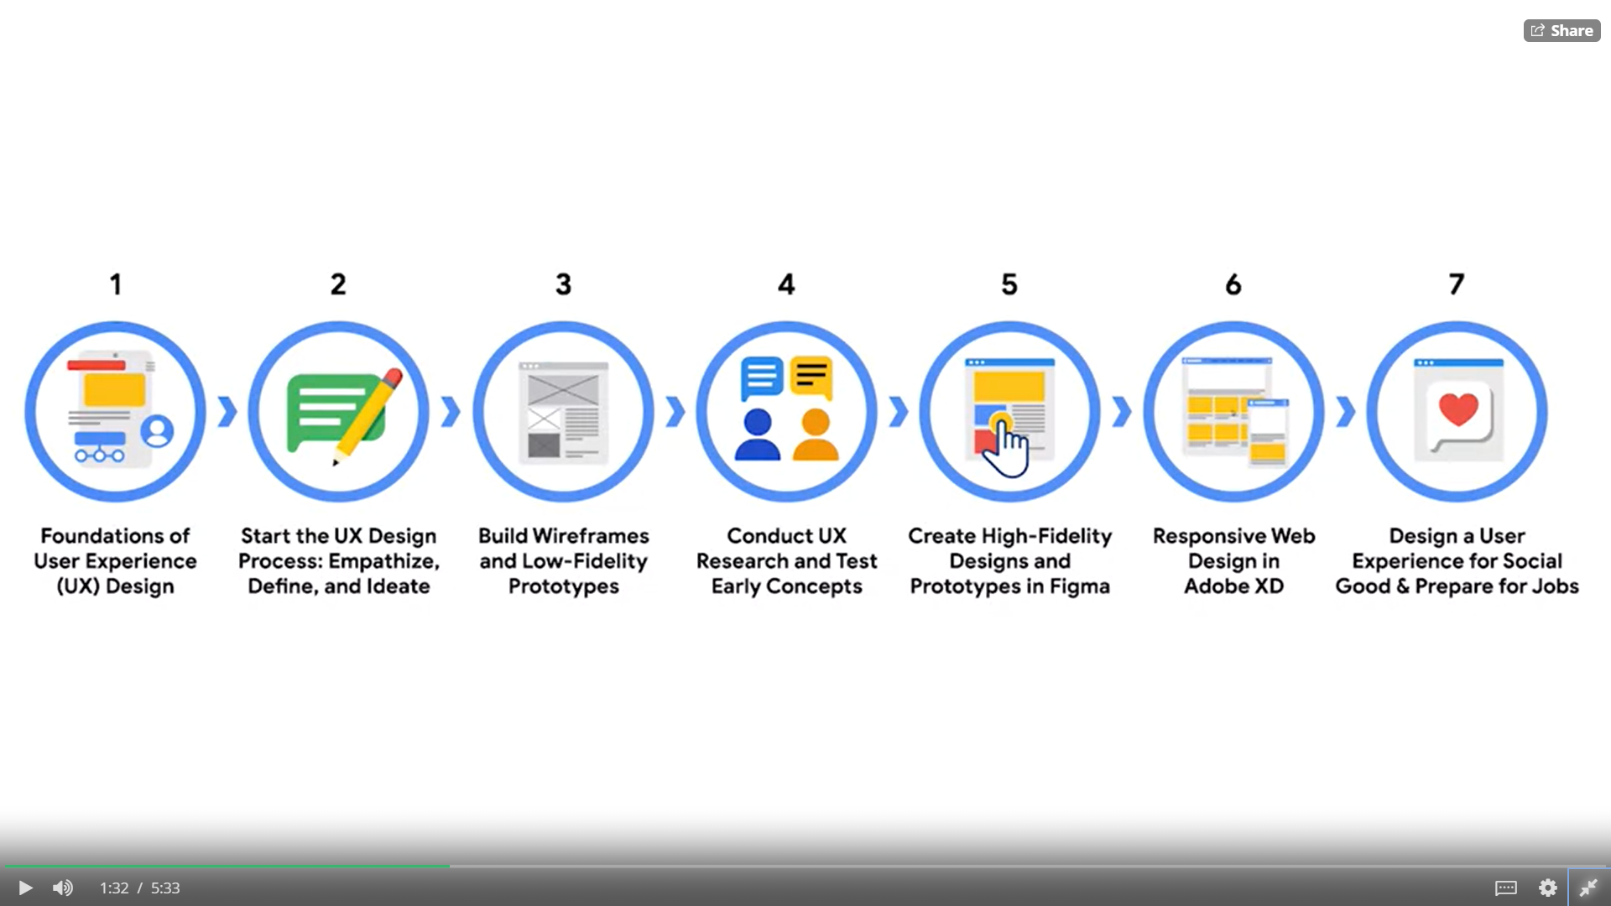

1. **Foundations of User Experience Design**
2. **Start the UX Design Process: Empathize, Define, Ideate**
3. **Build Wireframes and Low-Fidelity Prototypes**
4. **Conduct UX Research and Test Early Concepts**
5. **Create High-Fidelity Designs and Prototypes in Figma**
6. **Responsive Web Design in Adobe XD**
7. **Design a User Experience for Social Good & Prepare for Jobs**

**Week-1**

# 1. User Experience Design

The phrase "user experience" was first coined in the 1990s, by cognitive psychologist Don Norman, as technology use expanded and evolved.Although the term came about relatively recently, the principles of user experience actually stretch back thousands of years, all the way to ancient China, where the practice of Feng Shui began.

## **1.1 Basics of User Experience Design:**

In this we will learn about -

(a). Foundation of UX design.

(b). Common terms, tools and frameworks.

(c). How to plan and participate in design spirits.

**User Experience:-**

“The user experience is how a person, the user, feels about interacting with or experiencing a product.”

**Product:-**

“A product is a good, service, or feature. It might be a physical product.”

Example like a →

* Video game controller,
* A bag of potato chips,
* Technology product,
* Like an app,
* Website or smartwatch.

For a user to have a good experience, the product needs to be -

1. **Useable**
2. **Equitable**
3. **Enjoyable**
4. **Useful**
5. **Useable:-** User experience is about improving usability or making something easier to use. This means that the design, structure, and purpose of the product are clear to everyone.
6. **Equitable:-** Being equitable means your designs are useful and marketable to people with diverse abilities and backgrounds. User experience is also about making things enjoyable to use, which creates a positive connection between the user and the product.

1. **Enjoyable:-** Think about ordering takeout food online. When you search for a restaurant in Google or Yelp, you can see photos of dishes and read reviews from other people who have eaten there. This experience is enjoyable because you can make a more informed choice about what to order, leaving you feeling happier about the product.
2. **Useful:-** As humans, we want products that are useful, meaning they solve our problems. For example, if you're lost, a map app telling you how to get home is useful. But if the app can't find your current location, it's not so useful anymore.

### 

### 

### 

## **Jobs in Field of User Experience:**

UX designers come from a lot of different backgrounds: marketers, artists, teachers, small business owners, cashiers, or anything really. Rather than sharing similar work histories, UX designers tend to share common skills and interests instead.

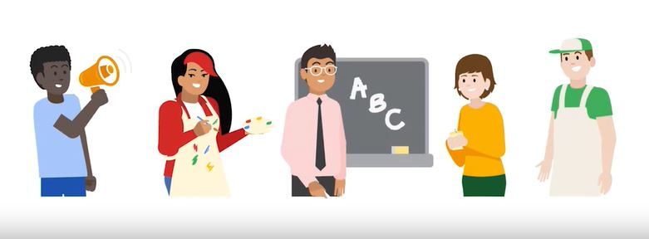

## **1.2 Product Development Life Cycle:**

Every new product, whether it’s an app or a physical object, follows a specific set of steps that take it from the first spark of an idea to the release of the final product. This is called the product development life cycle, and it has five stages: brainstorm, define, design, test, and launch.

Depending on where you work, the exact names of each stage might be a little different, but the overall process is generally the same.

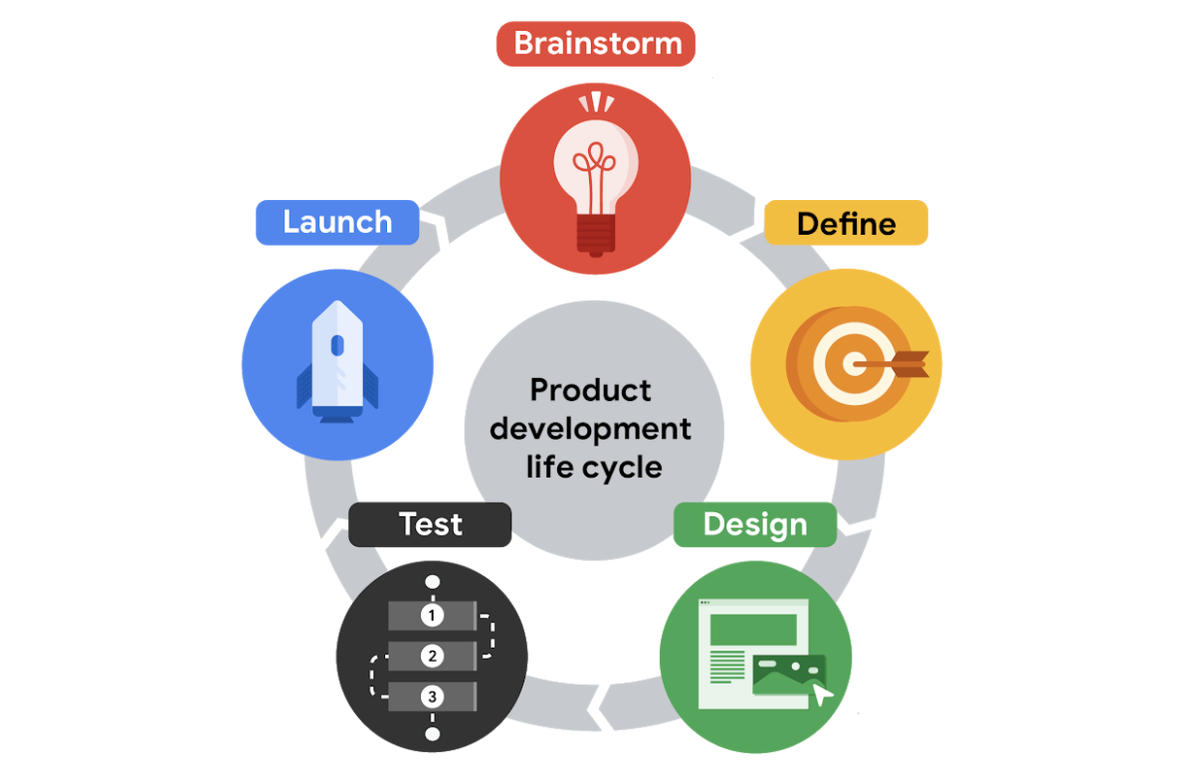

The product development life cycle and how UX design fits into each stage. As you might have guessed, UX designers are most engaged during the *design* stage of the product development life cycle, but they work closely with team members — like researchers, product managers, and engineers — throughout the entire life cycle.

As a product moves through the development life cycle, the team might need to spend longer working in one stage than in others, or repeat certain stages based on feedback. The success of each stage depends on the previous stage’s completion, so it’s important to do them in order.

Qualities needed in a product for users to have a good experience are: A product that’s useful, equitable, and enjoyable contributes to a good user experience.

## **1.3 Characteristics of Good User Experience:**

Good design is easy to spot but often hard to pin down. What exactly makes a product effective to its users? Is it a matter of simplicity, structure, or functionality? The answer depends on the product in question.

The basics of user experience design”, you were introduced to some primary characteristics of good UX. These characteristics—**usable, equitable, enjoyable, and useful**—can help you evaluate a product’s design.

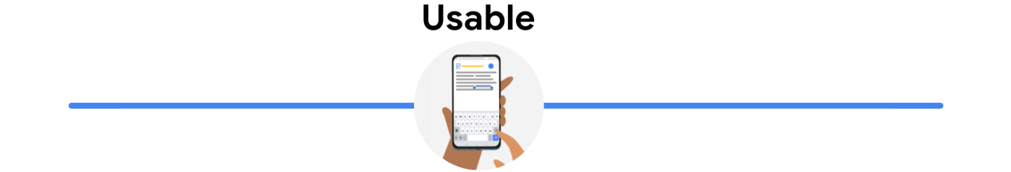

* If a product is usable, it means the design, structure, and purpose of the product is clear and easy to use.
* **For Example:** Imagine you are evaluating the usability of an airline app. Assuming the primary purpose of this app is to book a flight, the design should provide a clear and easy way to complete that task. For example, a section where you can easily enter travel and flight details on the homepage would be an example of good usability.

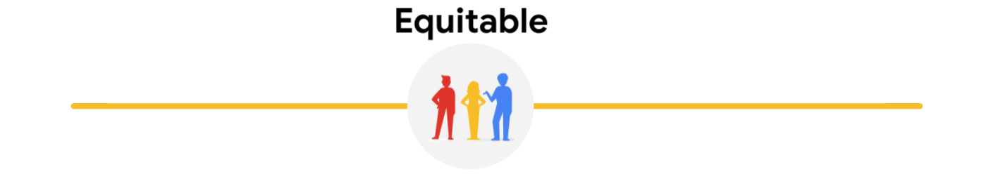

* If a product is equitable, it means a design is helpful to people with diverse abilities and backgrounds. In other words, the product’s design addresses the needs of a diverse audience and ensures a high-quality experience is delivered to all users regardless of background, gender, race, or ability.
* Equity means providing people with the tools they need to accomplish their goals and support improved quality of life.
* **For Example:** Imagine you are evaluating how equitable a social messaging app is. You might consider the design more equitable if the keyboard emoji list includes different skin tones and gender-neutral avatar options.

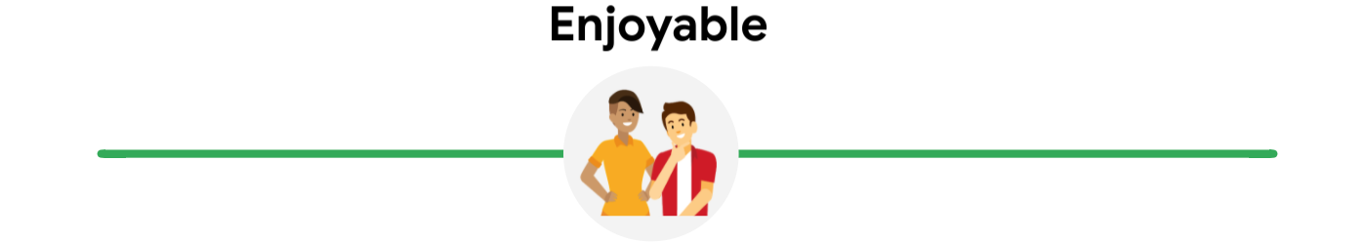

* If a product is enjoyable, it means the design delights the user.
* The design reflects what the user may be thinking or feeling and creates a positive connection with them.
* A product’s design doesn’t have to be enjoyable for it to function properly.
* **For Example:** Imagine you are evaluating how enjoyable a video streaming app is. Design aspects that might increase how much you enjoy the product include personalized recommendations based on previous watching habits, or the ability to customize the appearance of your account.

## 

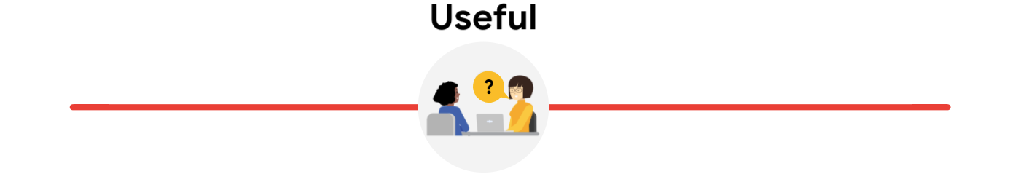

* If a product is useful, that means it solves user problems. In other words, the design intentionally solves a user problem that the designer has identified.
* It’s important to note that, while similar, useful and usable have different meanings. A product that is useful isn’t always usable. The same is true for the opposite.
* The distinction between the two is that usability refers to the product working well and being easy to use, while usefulness refers directly to the ability to solve user problems.
* **For Example:** Imagine you’re evaluating how useful a banking app is. Users typically download these apps because they need a place to manage their money. With this in mind, aspects of the app that might be considered useful are features that can be used to transfer money between accounts and pay bills.

## **1.4 Activity Exemplar:**

*The app images are provided below for easy reference:*

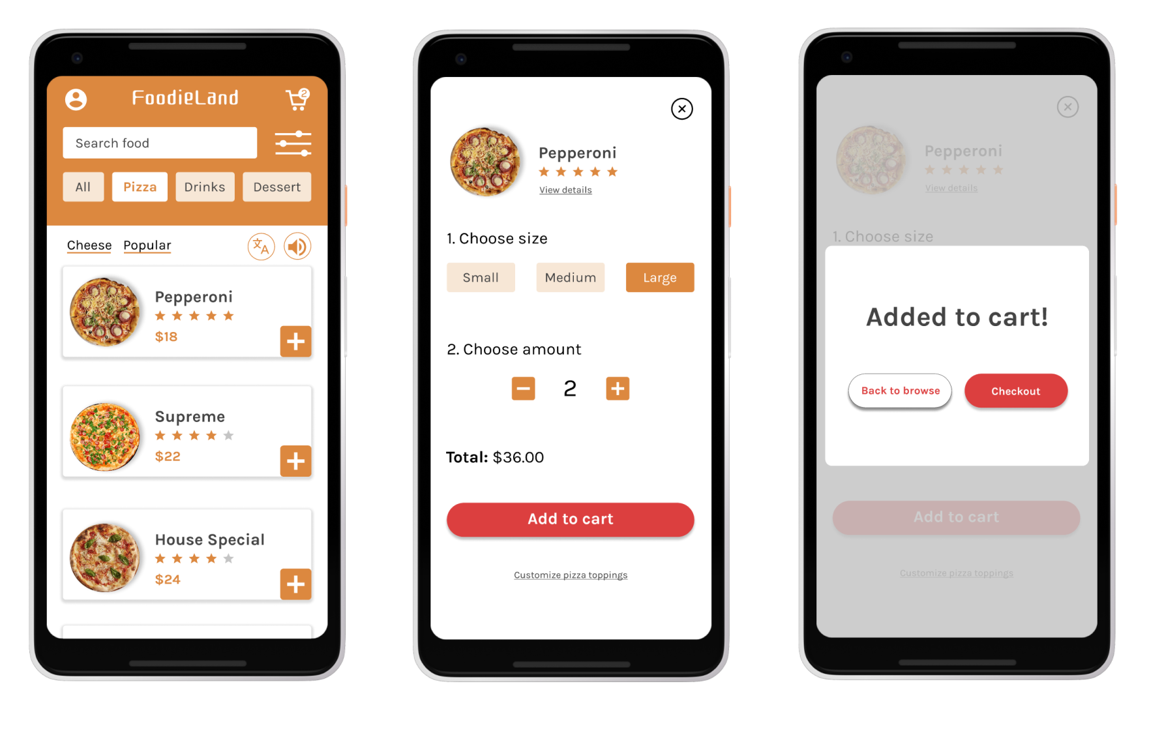

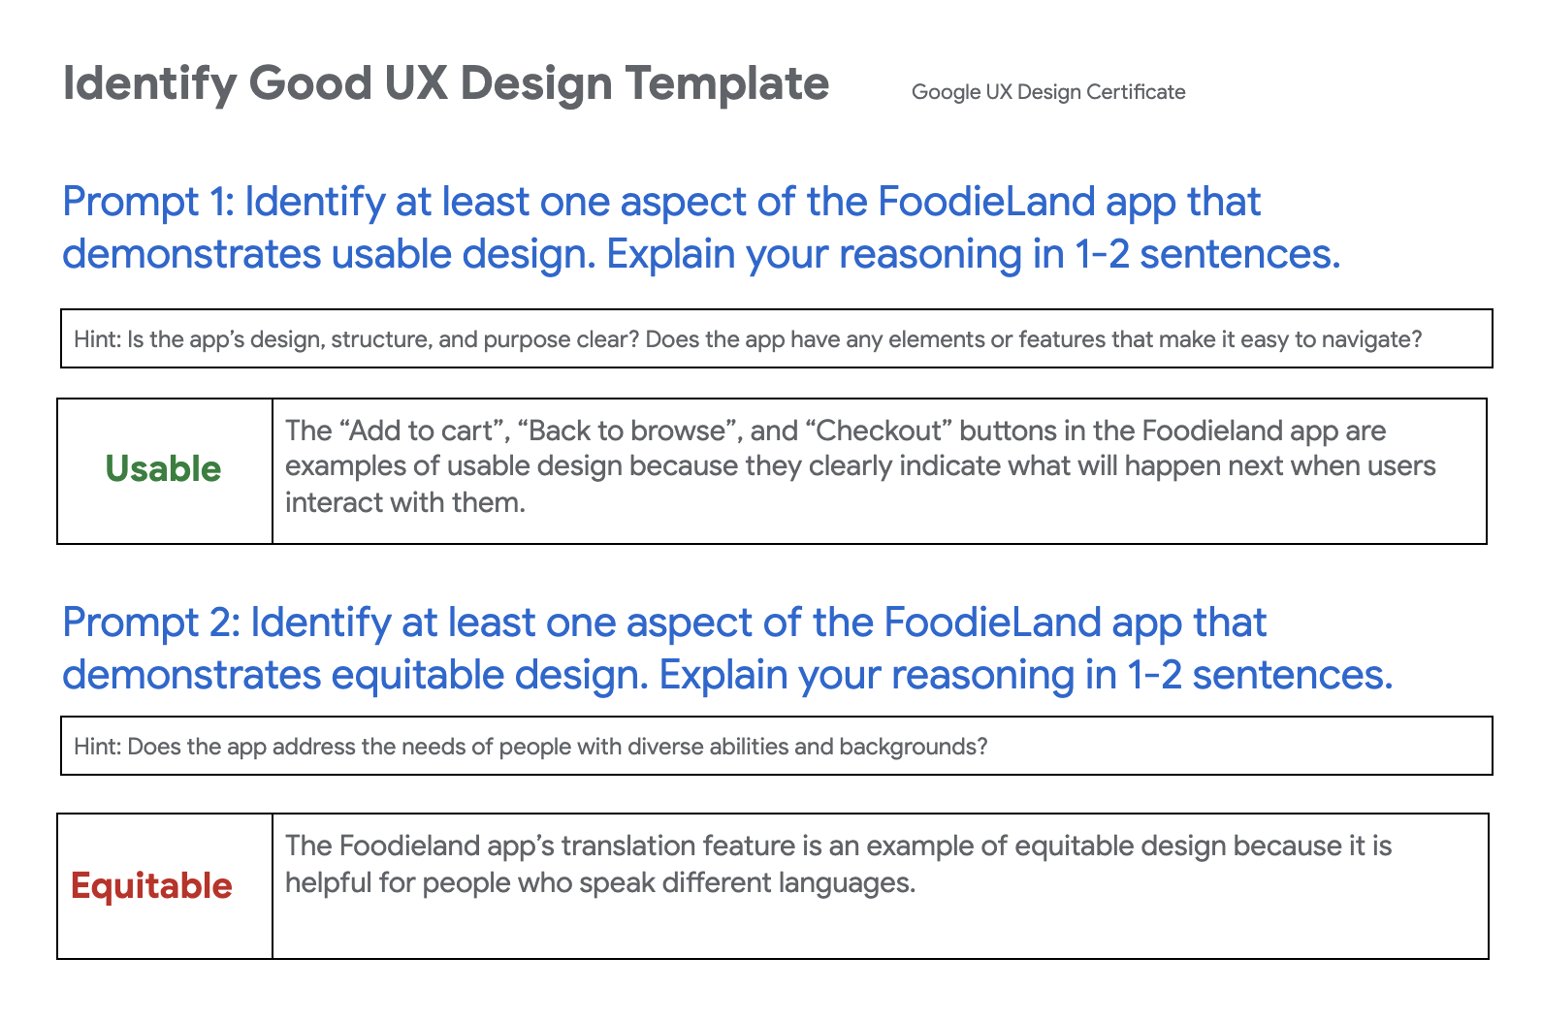

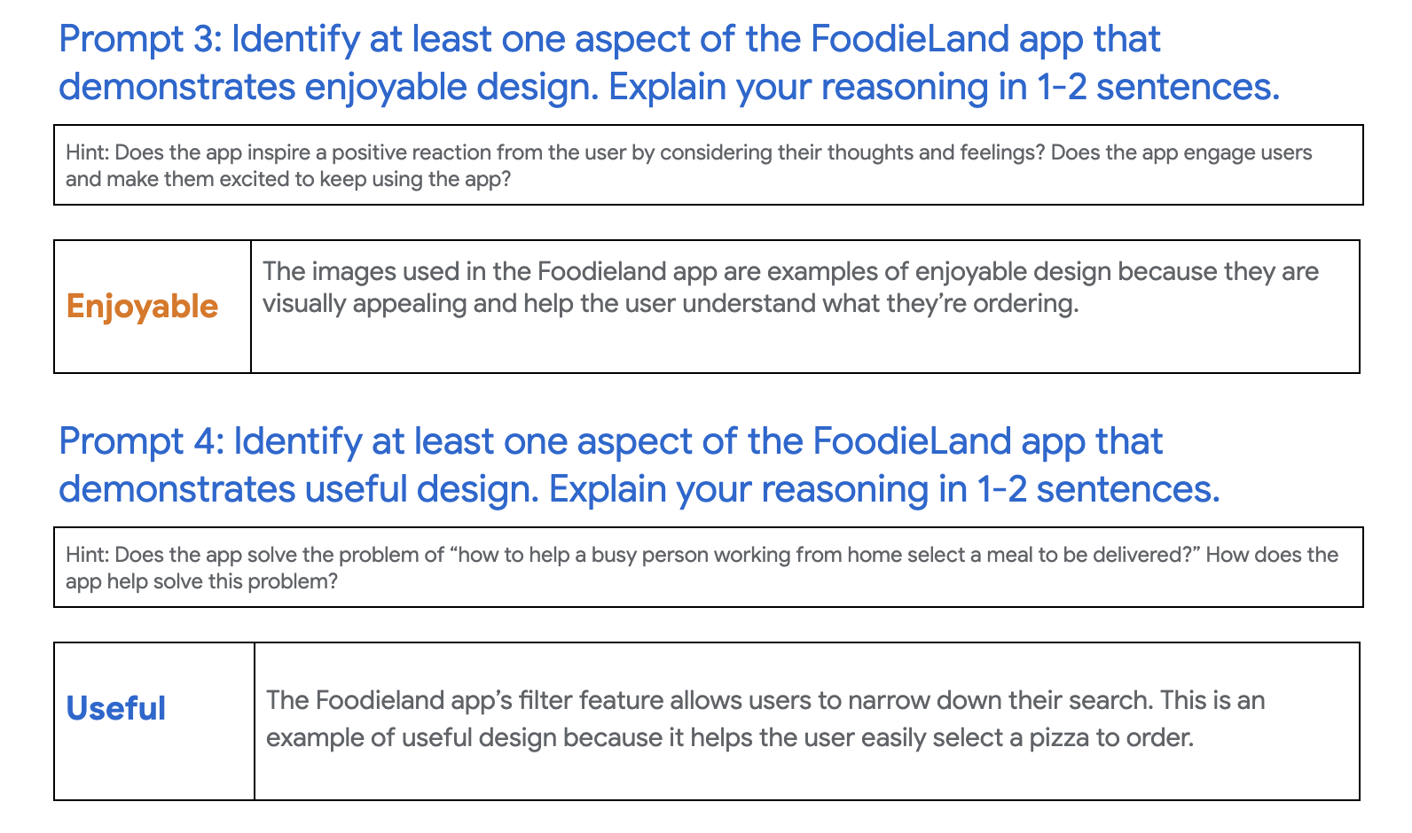

## **1.5 Responsibilities of Entry-Level UX Designer:**

As an entry-level UX designer, you’ll have a lot of exciting opportunities to gain experience. When you first start out, you’ll probably take on a lot of different roles and responsibilities.

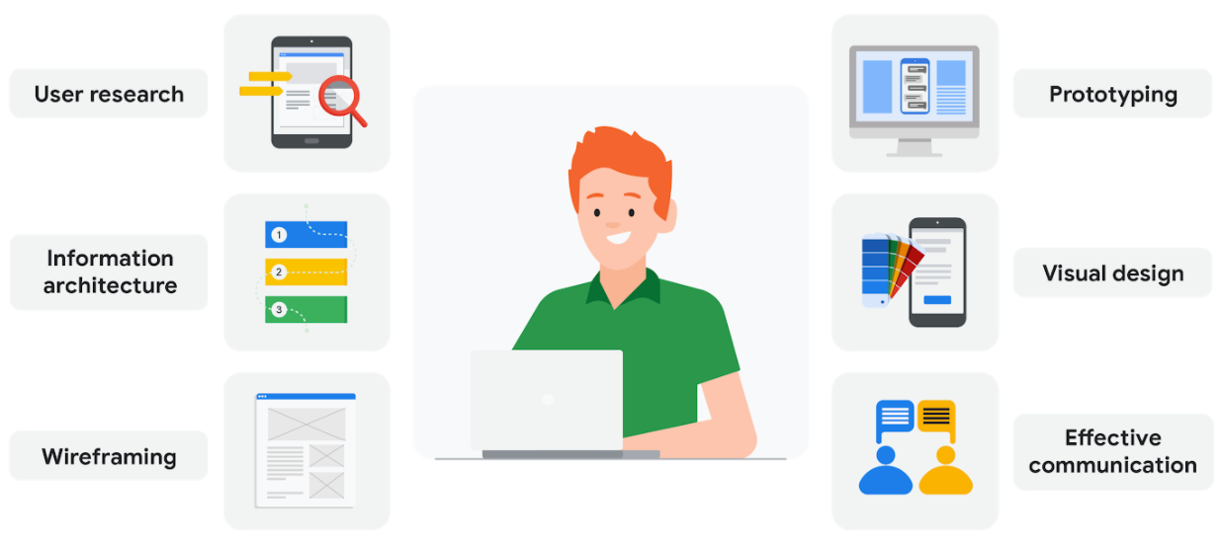

## **User research:** User research is about understanding the people who use your product. Through research, you’ll learn about users’ backgrounds, demographics, motivations, pain points, emotions, and goals. Your research methods might include surveys, observations, and interviews. We’ll explore user research in much more detail in an upcoming course.

## **Information architecture:** Information architecture, or IA for short, involves deciding how your product is organized and structured. Think of IA as a skeleton that outlines how users interact with your product. Everything in your product should be organized in ways that make sense to the user and meet their expectations.

## **Wireframing:** A wireframe is a basic outline or sketch of a product or a screen, like an app or website. As the name suggests, wireframes look like they were created with wires. They’re mostly lines and shapes, with some text. Wireframes can be drawn by hand or created digitally using software. Wireframing helps you bring your design ideas to life, so other people on your team can provide input and feedback.

## **Prototyping:** A prototype is an early model of a product that demonstrates its functionality. Prototypes can be in physical or digital formats and can vary in complexity. Sometimes a prototype is made to demonstrate one specific feature of a product, like the transition between screens or the way the product physically looks and feels. You’ll make multiple prototypes for any given product throughout the design process.

## **Visual design:** Visual design focuses on how the product or technology looks. As a UX designer, you need to understand the foundations of visual design in order to communicate the connection between a product’s functionality and its appearance to users. You’ll learn some of the most important principles of visual design throughout this certificate program.

## **Effective communication:** Effective communication as a UX designer means connecting with your colleagues through emails, meetings, presentations, and design software. UX design is a very collaborative field, so being able to communicate both digitally and face-to-face with teammates is important. You need to be a good listener, be receptive to feedback, and share your ideas in a clear way.

## 

## **1.6 Specialist v/s Generalist v/s T-Shaped**

## 

**Specialist:** A specialist dives deep into one type of UX design, like interaction, visual, or motion design, and becomes an expert. Specialist UX designers are more common at large companies that have a lot of designers, like here at Google. Some of the benefits of becoming a specialist include:

* Focusing on one type of design that you enjoy more than others.
* Gaining deep knowledge of one type of design.
* Becoming well-known in the industry for your expertise in a particular type of design.

**Generalist:** A generalist has a broad number of responsibilities. A majority of UX design jobs are generalist positions, especially at companies with fewer UX designers. Typically, entry-level UX designers work in generalist roles, and some people choose to stay in generalist design roles for their entire careers. There are a lot of benefits to being a generalist UX designer, like:

* Expanding your skills in many different types of UX work.
* Trying a variety of responsibilities and finding an area of UX that you’re especially passionate about.
* Keeping your job feeling fresh and new, while doing a variety of tasks.

**T-shaped:** A T-shaped designer is a specialist who also has a lot of capabilities in other areas. T-shaped designers get their name because the stem (or vertical line) of a T represents their expertise in one area, while the top (or horizontal line) symbolizes their related skills in a broad number of areas. T-shaped designers are great to have on your team, since they come with the benefits of both specialists and generalists. The image below highlights some of the skills a T-shaped UX designer might have. In this example, the person is a visual design specialist but also has knowledge in other areas, like coding and prototyping.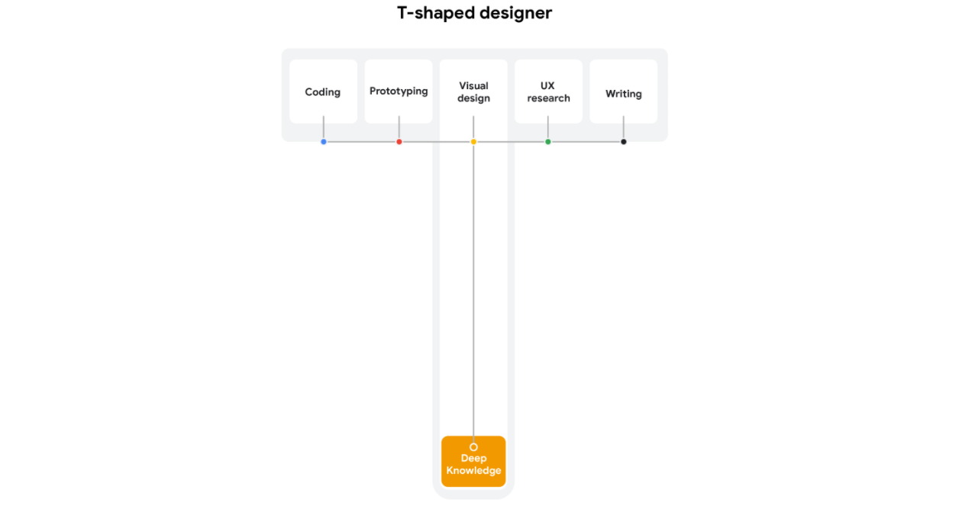

- Each designer tends to naturally have a little T-shape in their abilities, even at the beginning of their career.

- As you start to work on projects, you’ll probably notice where your strengths and interests lie. As you get better at one area of design, you’ll likely find yourself working on that part of design projects more often, which helps you continue to improve in one area.

## *Teams that UX designers work with:-*

## 

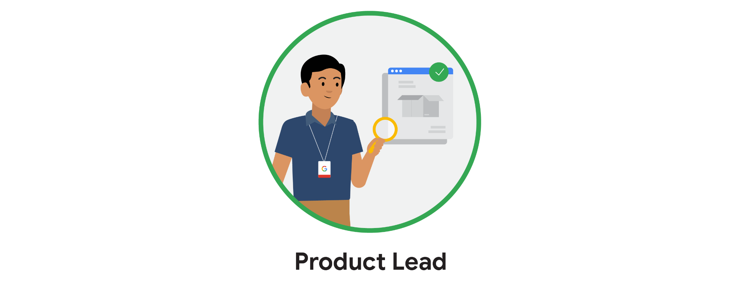 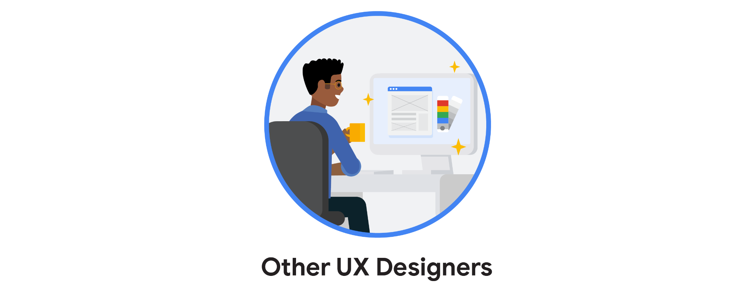

**Week-2**

# 2. UX Design Process

In the field of user experience design, one of the most important terms is **"user".** A user is any person who uses a product. In addition, the end user is the specific audience a UX designer creates something for. Our goal as UX designers is to think about problems and needs from the end user's perspective and design an experience to meet those needs.

Think of it like this: An animated movie about talking cars is designed with **kids ages** **5 to 7 i**n mind. Those kids are the movie's end users, but adults and teenagers will be in the audience too. So they are also users.

## **2.1 User-Centric Design:**

Why is it important that designs are centered on the user? Because the user buys and uses your product. 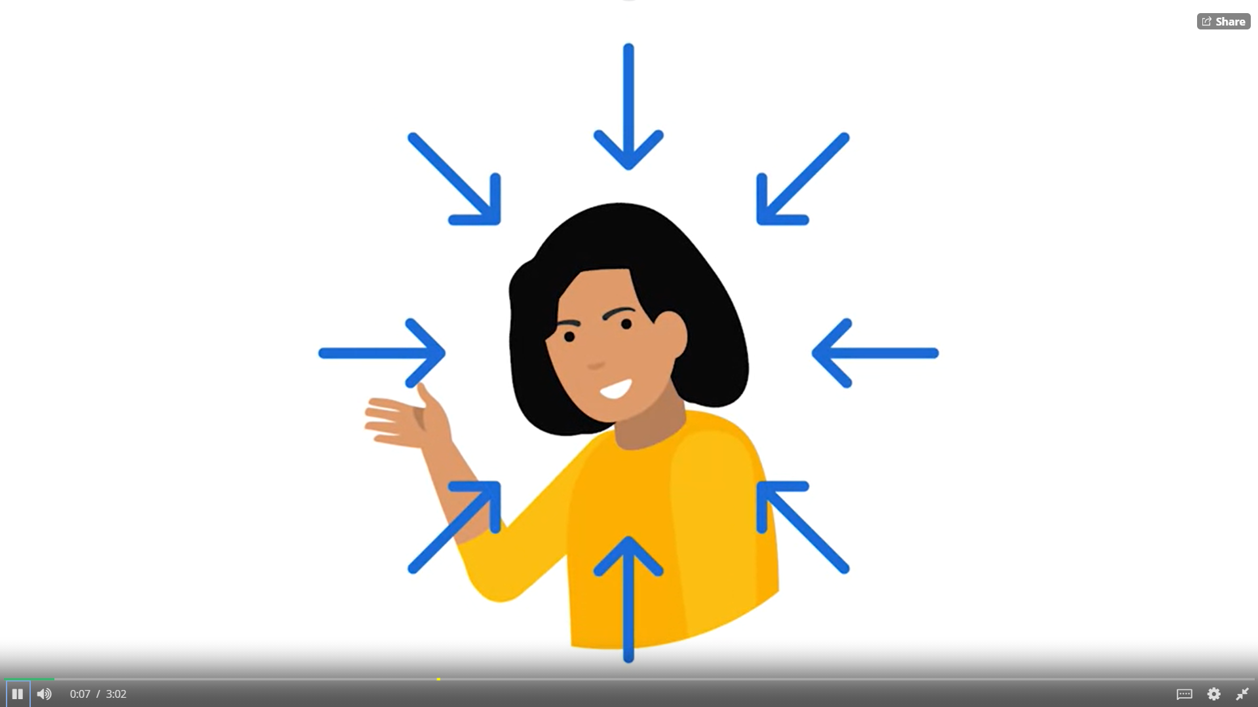

User-centered design puts the user front and center. Focusing on the user means considering their story, emotions, and the insights you've gathered about them.

To keep our focus on the user, the user-centered design process has four steps: understand, specify, design, and evaluate.

*User-centered design is a framework that puts the user front-and-center. By focusing on the user, designers must consider the story, emotions, and insights gathered about them.*

To keep our focus on the user, the user-centered design process has **four** steps: **understand, specify, design, and evaluate.**

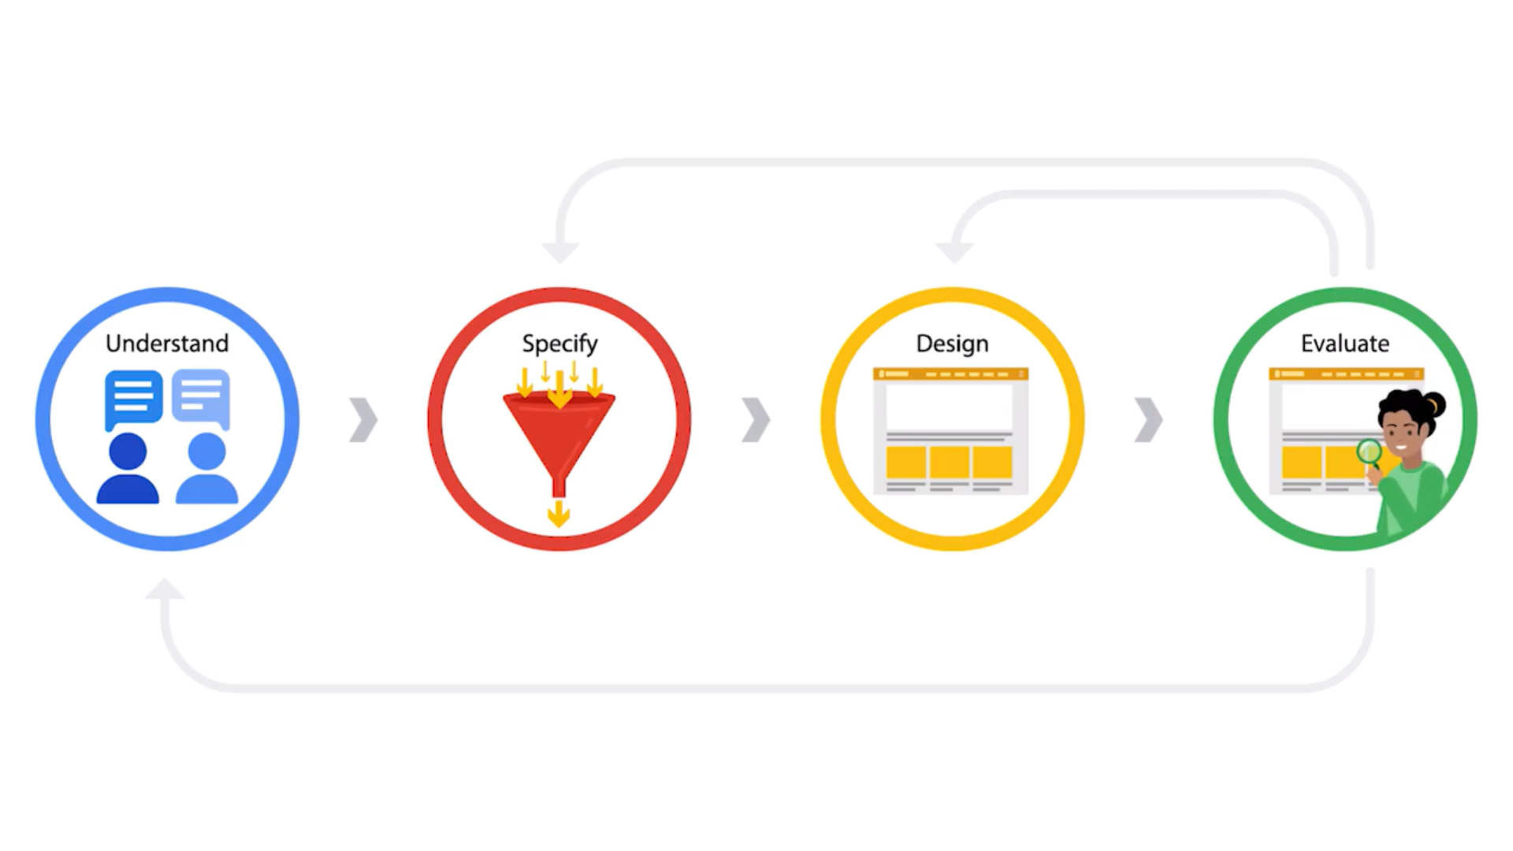

## **2.2 Key Frameworks in UX Design:**

## **Frameworks -** Creates the basic structure that focuses and supports the problem you're trying to solve.

There are **two** types of framework, i.e,

***[1]. Five Elements Framework***

***[2]. Design Thinking Framework***

***[1]. Five Elements Framework***

The five elements of UX design is a framework of steps a designer takes to turn an idea into a working product. This framework consists of, wait for it, five elements: strategy, scope, structure, skeleton, and surface.

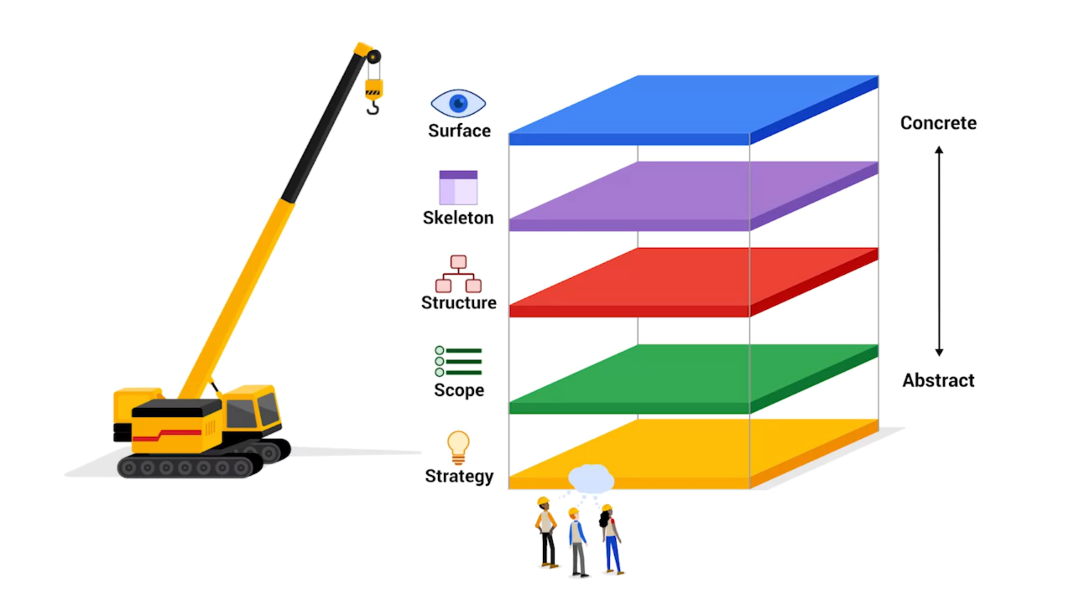

**Strategy:** This is where we will define the user's needs and business objectives.

**Scope:** This is where we will determine what you're building. You'll decide on features and content to be included in the product.

**Structure:** This is where we will figure out how to organize your design and how the user will interact with it.

**Skeleton:** This is where we will think of the layout. Similar to how the layout of our bones shape our skin, this layer helps detail how the design works, but just like our bones, the user won't see these inner workings.

**Surface:** Instead, we will see the surface, which is the top level of the user experience. The surface is how the product looks to the user.

***[2]. Design Thinking Framework***

Design thinking. Design thinking is a way to create solutions that address a real user's problem and are functional and affordable. Design thinking has **five** actionable steps: **empathize, define, ideate, prototype,** and **test.**

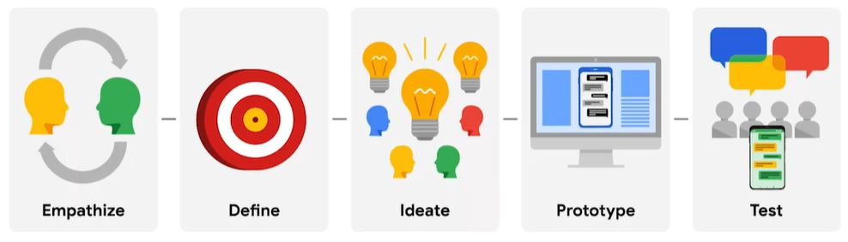

**Empathize:** Which is about discovering what end users really need and learning how to think and feel like them. We might conduct surveys, interviews, or observation sessions to paint a clear picture of who your end users are and the challenges they face.

**Define:** It defines the problem by creating a clear problem statement. The problem statement is a clear description of the user's need that should be addressed. The problem statement should be based on user research and it focuses the team on a clear goal.

**Ideate:** Once we have defined the problem, we can start to ideate or brainstorm solutions. You should aim to come up with as many ideas as possible. By focusing on the quantity of the ideas, not the quality, we are more likely to come up with innovative solutions.

**Prototype:** A prototype is a scaled down version of a product that shows important functions. You should have a clear goal for your prototype in mind.

**Test:** Finally, we test the prototypes with users. Testing keeps the user front and center as it gives users an opportunity to provide feedback before the product is built. Based on user feedback, we can make changes and improvements or come up with a completely new idea.

## **2.3 Four Cs of Designing:**

## The four Cs of designing for multiple platforms are: **consistency, continuity, context,** and **complementary.**

## 

## **Consistency:** Most companies have specific design guidelines that need to be followed in order to stay consistent with their brand identity, which refers to the visual appearance and voice of a company. When designing a product, it’s essential to stay true to the company’s brand guidelines in order to maintain consistency across platforms and drive brand awareness. Maintaining a consistent design helps improve the user experience and build trust, because users can expect the design to feel familiar across platforms and products.

## A graphic of a laptop and a phone next to each other. On the laptop, there's an email draft. Same draft is on the phone.

## **Continuity:** To provide users with a seamless experience as they move between platforms, UX designers also have to prioritize continuity. Continuity in design means that users can maintain their progress as they move from one platform to the next. The user experience for each platform might be slightly different, but the product’s functionality should still be connected. Without continuity, users can become frustrated if the progress of their experience does not carry across platforms.

## A graphic of a laptop screen next to a smart watch screen. Email appears on laptop, notification appears on the watch.

## **Context:** It’s also important to consider the context of each platform you’re designing for. This means thinking about when and how users prefer to interact with certain features on different platforms.

## A graphic of a laptop next to a phone screen. On the laptop, hands are typing an email. On the phone, they are adding images

## **Complementary:** One way to create a great cross-platform user experience is to make sure that the design of each platform adds something new for the user. Taking into account how each platform could uniquely enrich the overall user experience is the best way to create complementary UX designs.

## **2.4 Examples of Cross-Platform Experiences:**

Now that you have the hang of designing across platforms, check out some real-world examples of products with stellar cross-platform user experiences.

**YouTube**

For a lot of people, [YouTube](https://www.youtube.com/) is a go-to source for watching endless hours of video content. The YouTube mobile viewing experience complements and smoothly transitions from a desktop browser.

**WebMD**

[WebMD](https://www.webmd.com/) is a healthcare website where users can learn about the symptoms, diagnosis, and treatments related to a wide variety of medical conditions. The WebMD “Symptom Checker” allows users to click on certain areas of a body map and get a list of possible symptoms associated with those body parts.

**Airbnb**

[Airbnb](https://www.airbnb.com/) is an online rental platform where users can list their own space to rent or book a stay in someone else’s space. The Airbnb user experience on a desktop computer is straightforward and similar to other rental sites, where you can filter your search based on your needs. The mobile app seamlessly integrates these same features and allows for continuity throughout the booking process.

## **2.5 Equity-Focused Design:**

Equity-focused design means thinking through all the aspects of a designed product and making sure the product is both accessible and fair to all genders, races, and abilities. Plus, the designs need to specifically consider underrepresented and excluded groups. Job applications and census forms are one area where gender and race needs specific attention, because they usually involve collecting sensitive data from users.

We might have already heard about the importance of having gender neutral pronouns on these kinds of forms, but that's actually just a starting point. When designing these forms, you should also consider whether a certain question even needs to be included in the first place. Ask yourself why you're collecting this information and whether or not you really need it.

**Week-3**

# 3. Design Sprint

# Design Sprint - A design sprint is a time-bound process with five phases typically spread out over five full, eight-hour days.

**Goal of Design Sprints -** To solve a critical design challenge through designing, prototyping, and testing ideas with users.

* A design sprint can answer critical business questions to design challenges.
* The goal of a design sprint is to solve a problem through designing, prototyping, and testing ideas with users.
* At Google, we use design sprints to answer questions, define product directions, figure out cross-team strategies, and even build team culture.

## **3.1 Benefits & Five Phases:**

Design sprints generally include five phases: **understand, ideate, decide, prototype,** and **test.**

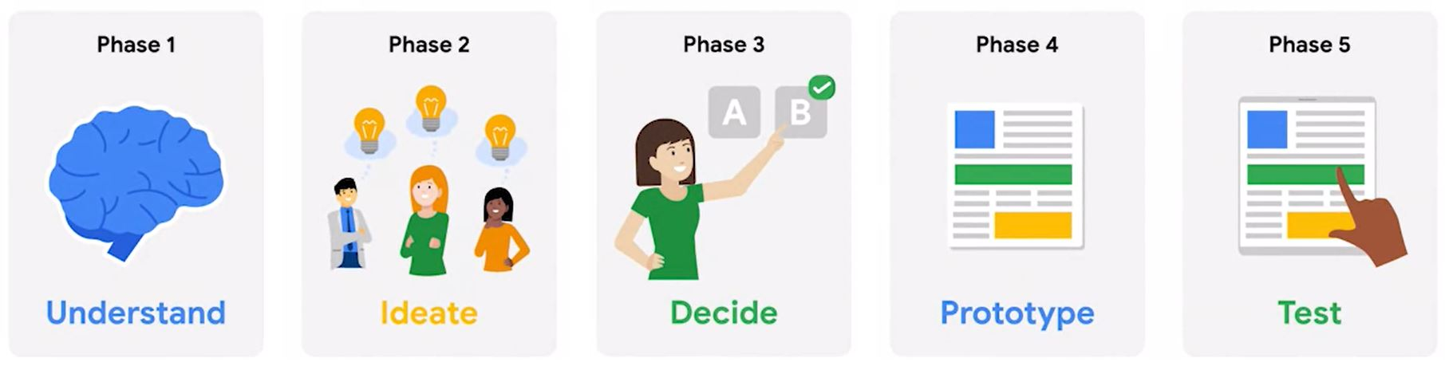

**Design Sprints Benefits:**

* Save time.
* Create a path to bring a product to market.
* Prioritize the user.
* Test product before launch.
* It’s all about the user.
* Value every person in the room.
* The best ideas to rise to the top.
* Time to focus.
* Lowers risks.
* Versatile scheduling

## **3.2 Plan Design Sprint:**

We've defined the design sprint, identified the five phases, and explored what goes into planning a successful sprint.

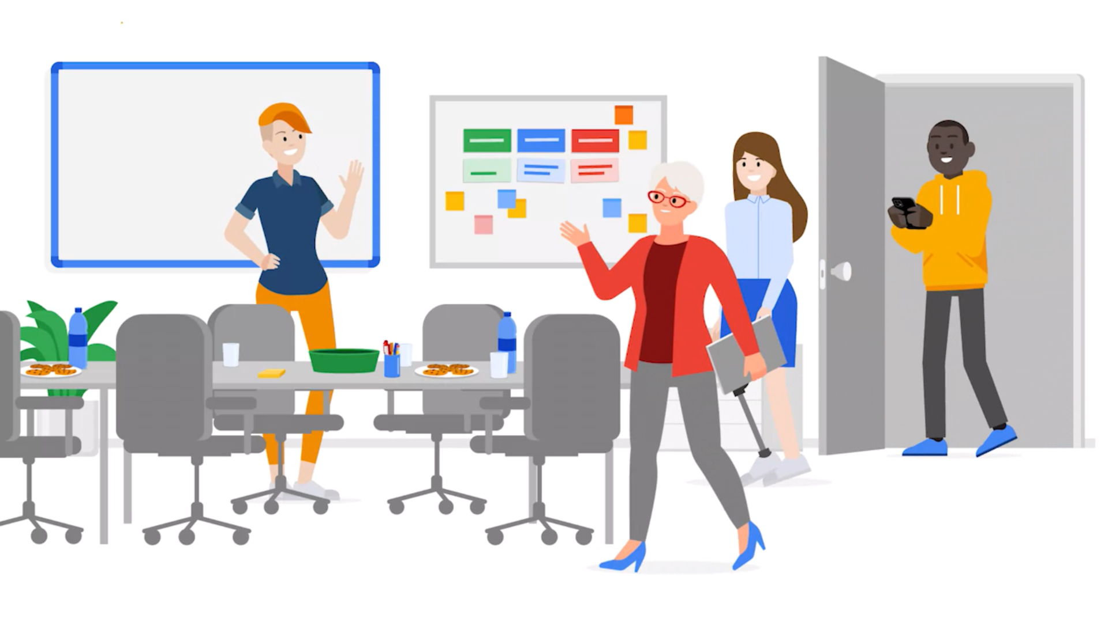

As an entry-level UX designer, you won't be running the show, but you'll play an important role contributing to every phase of the sprint.

Let's check out what your sprint week might look like. When you get to the sprint space, you'll find everything you need to do your work. You'll have office supplies, water to drink and maybe some snacks. The sprint leader will welcome everyone and lay out some ground rules.

## **3.3 Design Sprint Phases:**

## **Phase-1 Understand**

## *The first one is the understanding phase, where we'll get a clear picture of the design challenge.*

## *There will be plenty of short talks by experts that are designed to inspire you. Make note of any thoughts we have.*

## **Phase-2 Ideate**

## *The sprint leader will guide the team through brainstorming activities to spark creativity and generate many possible solutions to the design challenge.*

## *Our main focus is coming up with ideas and putting them out there.*

## **Phase-3 Decide**

## *Now our team will decide on the solution with the greatest chance of success. As a newbie UX designer, we'll get involved in every stage of the decision-making process. When potential solutions fight it out, we’ll vote for the one we think has the most potential.*

## *We also need to start planning ahead for testing or phase 5 of the design sprint. As an entry-level UX designer, we might help by scheduling testers, creating survey or interview questions, and gathering necessary equipment.*

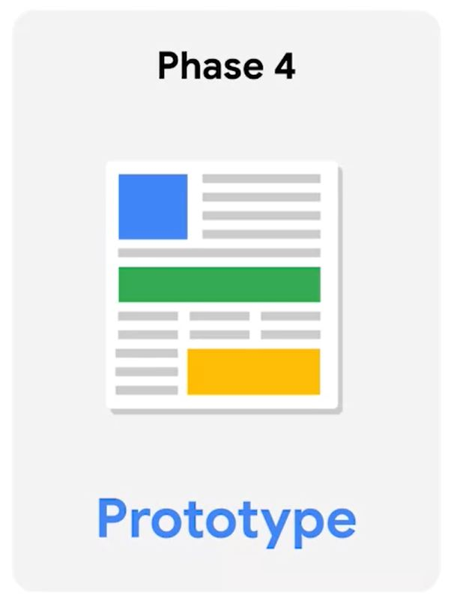

## **Phase-4 Prototype**

## *It is all about creating a prototype of our product. As an entry-level UX designer, we'll be actively involved in creating a solid prototype for users to try out.*

## *We'll ask questions, offer ideas, and review the completed prototype.*

## **Phase-5 Test**

## *We've made it. It's a test day. The test phase is the final phase of the process where we put our prototype to the test. We might be asked to collect user feedback by observing and interviewing users.*

## *This feedback helps the team know what to revise before bringing the product to market and that's it.*

## **3.4 Design Sprint Retrospectives:**

The retrospective is a collaborative critique of the team's design sprint. We usually do retrospective meetings immediately following the sprint so that everyone's thoughts are fresh.

* Retrospective meetings don't have any particular agenda.
* The goal is to make sure everyone who took part in the sprint has a chance to give feedback.
* The two key questions we aim to answer in the meeting are:

*(a). "What went well?"*

*(b). "What can be improved?"*

* Retrospectives are super useful.
* They can help you to work better as a team, improve how you communicate with clients, and even point out areas where we can grow as an individual.
* Retrospectives are all about empowering, not shaming.
* If something didn't go well, this is your chance to make sure we have the resources and the tools to do better next time.

**Week-4**

# 4. Build Professional Presence

In this we’ll learn about...

* What a portfolio is and why do UX designers use them?
* How to choose a website builder for our portfolio and start to create our website?
* How to demonstrate our unique value and personal brand through the story we tell?
* How to describe our work concisely and articulately?
* How to create a consistent online presence; and finally?
* How to network with others and find a UX design mentor?

## **4.1 UX Design Portfolios:**

Our goal is to learn the skills we need to get a job as an entry-level UX designer. But how do we demonstrate those skills during the job application process? That's where portfolios come in.

**Portfolio -** A portfolio is a collection of work that you've created that shows your skills in a certain area, like painting, photography, or UX design.

**Visual Designer -** It is a user experience designer that really focuses on the creative expression of a user experience.

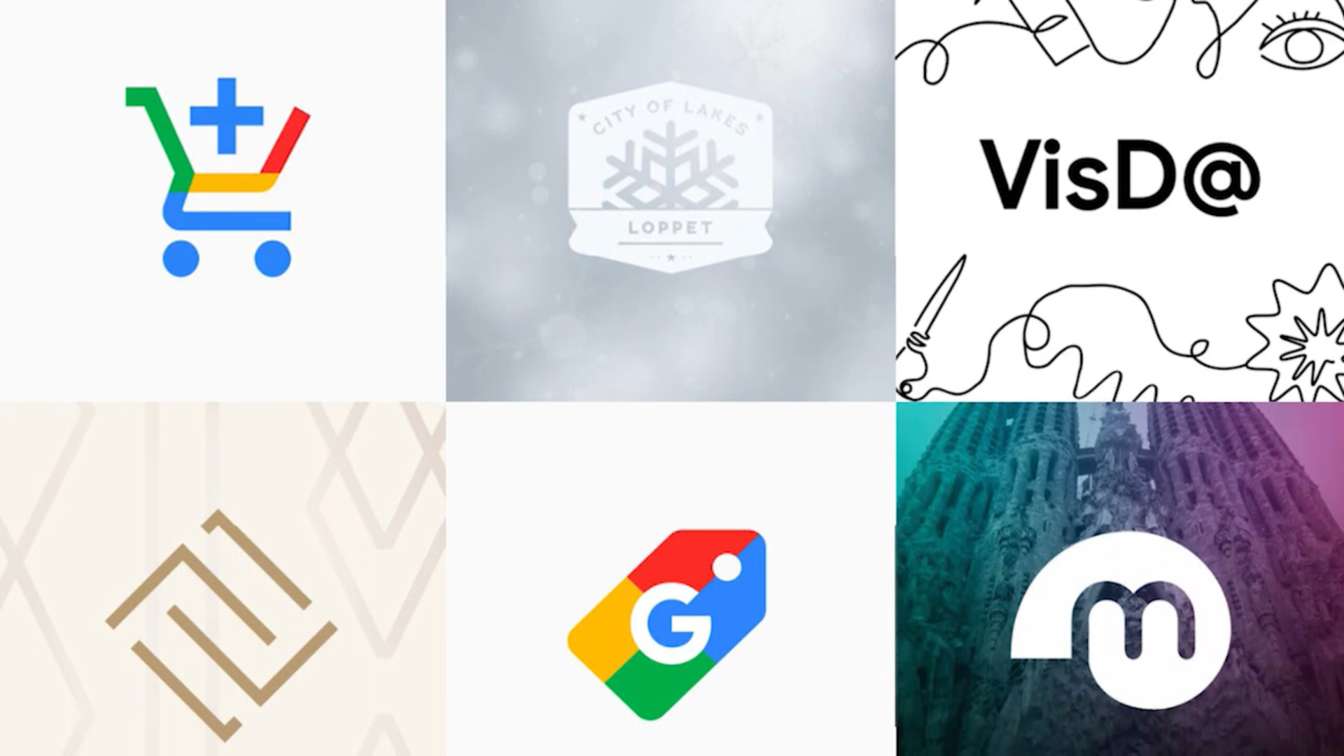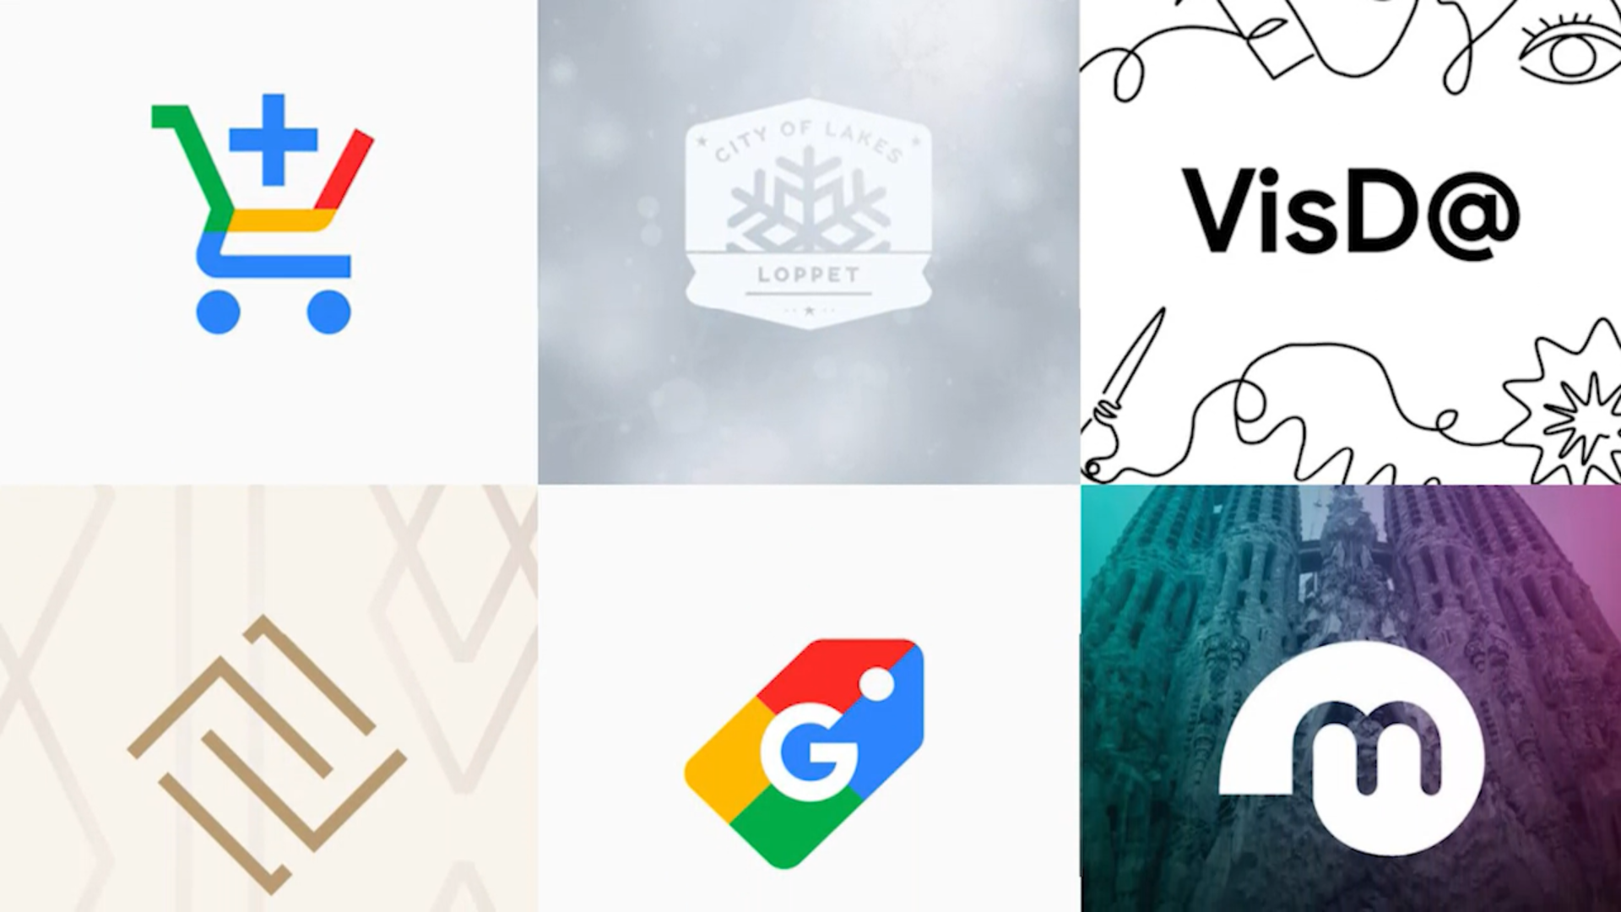

In the past, portfolios were usually a physical collection of work like a giant briefcase full of drawings. But in today's world, it's more likely that our portfolio will be on a website, which is much easier to update and share. Next, we'll build our own website to showcase our future portfolio. We don't need to know how to write code or have any work to include yet.

* Creating a showcase of your work and skills is a great way to start feeling like a part of the UX design community.
* Keep in mind that the design of the website itself is also important.
* Having a well-designed website is another way to demonstrate that we understand the principles of UX design.
* We wouldn't want our website to have a bad user experience when we're applying for a job in UX. As we design the website, we want our portfolio to tell a story and grab the user's attention.
* After all, the user might be a recruiter or a client interested in offering us a job.
* Next up, we'll meet entry-level UX designers, explore real-world portfolios, and learn how those portfolios help lead to jobs in UX design.

## **4.2 Portfolios to Examine:**

Review the list of entry-level UX designers at Google below.

* Lisa - [www.lisasuefischer.com](http://www.lisasuefischer.com/)
* Shabi - [www.shabnamkashani.com](https://www.shabnamkashani.com/)
* Dane - [danegalbraith.com](https://danegalbraith.com/)
* Nicolas - [www.nicolaspellegrino.com](https://www.nicolaspellegrino.com/)
* Josh - [joshglucas.com](https://joshglucas.com/)
* Kartik - [www.kartikrao.in](http://www.kartikrao.in/)
* Kaiwei - [kaiwei.design](http://kaiwei.design/#/)
* Anqi - [www.anqiwan.com](https://www.anqiwan.com/)
* Carson - [www.carsonyoung.ca](https://www.carsonyoung.ca/)
* Tongfang - [www.tongfangsun.xyz](https://www.tongfangsun.xyz/)
* Penny - [pennybanks.com](http://pennybanks.com/)

## **4.3 Website Builders:**

## *How to build a personalized online portfolio? .*

## 

Building a website might seem intimidating, but there are a lot of tools to help us. Most website builders are simple to use and *don't require any coding or technical knowledge.*

Plus, they have a support team on staff to help. Website builders often have tutorials to help us figure out what layout to use, and how to add text, sound, and images. These user-friendly website builders feature *WYSIWYG editors.*

**WYSIWYG -** Stands for **What You See Is What You Get.**

## **Quiz: What beneficial features do website builders offer UX designers when building a personalized online portfolio?**

## **Tutorials with guidance on how to add text and multimedia elements**

## *Website builders offer user-friendly editing features, tutorials and even some templates so users do not need to start from scratch.*

## **User-friendly editing features**

## *These builders feature user-friendly WYSIWYG editors, offer tutorials and even some templates to start from. WYSIWYG is an acronym that means: what you see is what you get. Common website builders include Squarespace, Wix, and Webflow.*

* Now let's check out some common website builders used by UX designers to build portfolios.
* There are lots of options for website builders. We'll focus on three of the most popular: **Wix, Squarespace,** and **Webflow.**
* They all have benefits & drawbacks. So choose that works best for us.
* Don't worry that our portfolio might look similar to our classmates'. Variety of templates are available.
* We have to personalize our template to convey our unique style, communicate the value we bring to the UX design industry, and showcase our designs.

## **4.4 Choose Right Platform:**

## 

Using a website builder is a great way to showcase your UX design skills and get started when you're new to the field.

### **[1]. Squarespace**

[Squarespace](https://www.squarespace.com/) is a great option for UX designers who are new to website building. When you sign up, Squarespace shows a variety of templates that you can easily customize to your liking, including color schemes and fonts. You can visit this page for a [full list of Squarespace’s features](https://www.squarespace.com/feature-index). You can also check out the [Getting Started guide](https://support.squarespace.com/hc/en-us/articles/206756327-Getting-started) on Squarespace for additional portfolio tips.

### **[2]. Webflow**

[Webflow](https://webflow.com/) is a creative tool designed for flexibility and is a strong website builder if you want to make a truly unique portfolio. You’ll have full control over your website’s design and a blank canvas to build upon. Having a basic level of HTML and CSS will help you with the Webflow learning curve. If you don’t have any experience with coding, you can visit [Webflow University](https://university.webflow.com/) to find lessons on specific things you want to learn.

### **[3]. Wix**

[Wix](https://www.wix.com/) is a strong choice to create your portfolio website without needing to code. Wix is known for its intuitive technology and user-friendly drag and drop editor, so you can have your portfolio available online in no time.

### **[4]. Google Sites**

[Google Sites](https://sites.google.com/new) is Google’s free platform for building websites. It’s a great option for anyone looking for a simple and affordable way to build an online portfolio. Google Sites offers a variety of useful features, like easy collaboration and sharing, as well as storage right in your Google Drive for easy access.

## 

## **4.5 Explorer Personal Brand:**

* Our personal brand is the way in which our personality, unique skills, and values as a designer intersect with public persona.
* We want our brand to be as vivid and well-defined as possible so we can leave positive lasting impressions and stand out as a designer.
* A strong personal brand should be widely-recognized and consistent.

# (i). Start to develop a personal brand:

# Your personal brand should be recognizable across all of your online presence, such as your portfolio website, LinkedIn, and UX design community profiles like Dribbble and Behance, which you'll learn about soon.

# Here are some pro tips to help you start to develop your personal brand.

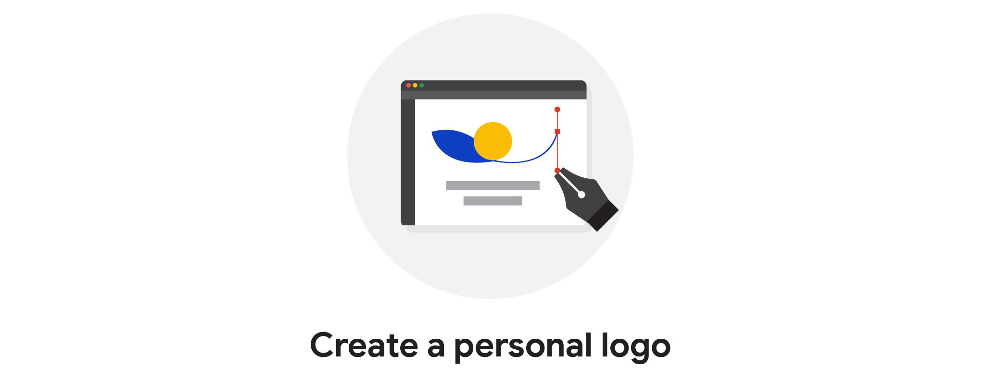 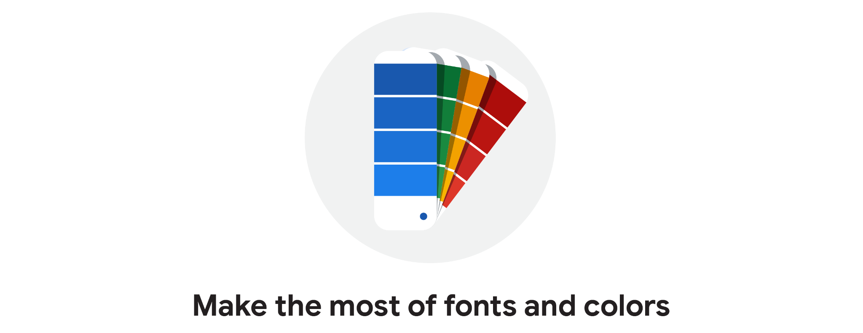 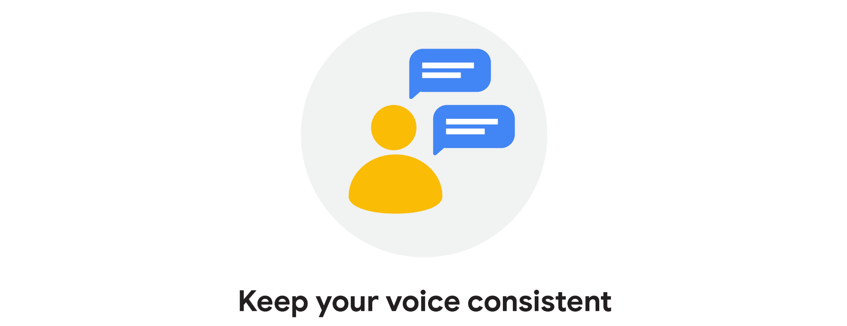

Create Personal Logo Make Fonts and Colors Keep our Voice Consistent

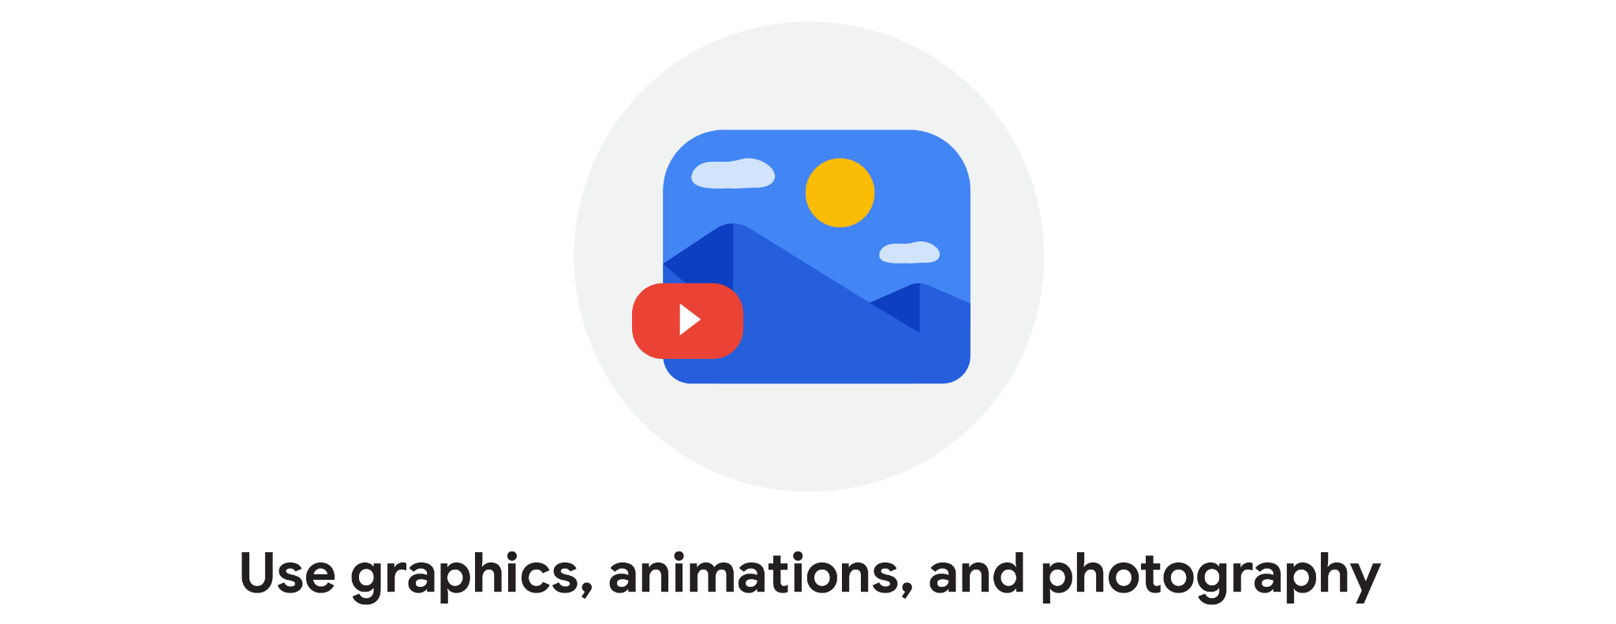 

Use Graphics, Animations Be Yourself

**(ii). Use writing best practices in a portfolio:**

The introduction to you and your portfolio should go above the fold on the homepage of your website. The term "above the fold" comes from the design of a newspaper.

If you're holding a newspaper in your hands, the most important information is on the top part of the front page, before you unfold it or flip it over. The same concept applies to websites.

**For Example -** *"Hi, I'm Michael. I believe that creative collaboration between design and technology is the magic that takes experiences from good to great."*

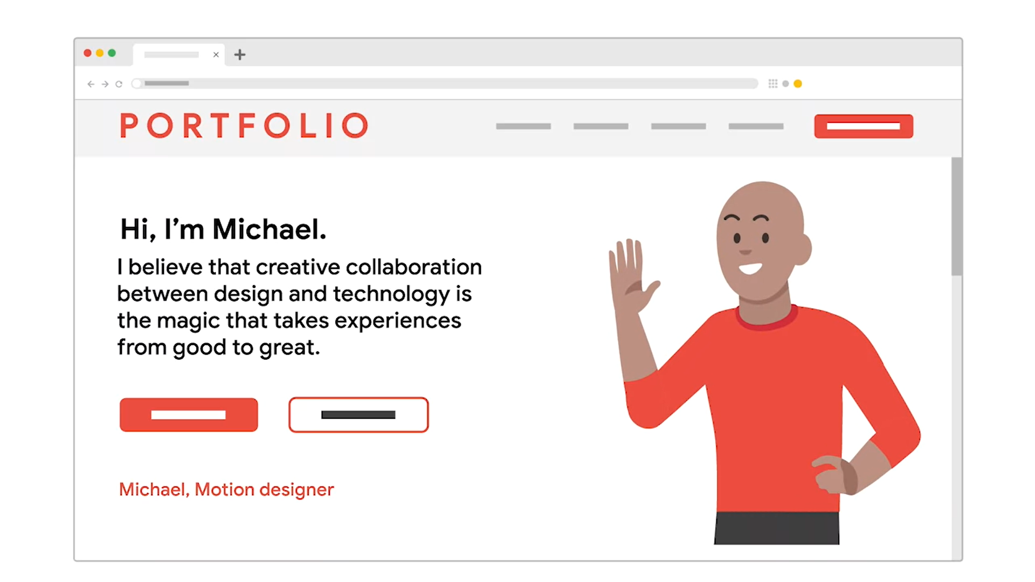

# In the above example, if a recruiter is searching for a motion designer and can immediately tell that's our specialty by glancing at the introduction on our homepage, then great -- they're more likely to continue going through our portfolio. But if our homepage uses vague language or doesn't communicate anything at all, the recruiter might not bother going further.

**(iii). “About me” Page:**

You can write in more detail on your About Me page, since you want potential employers and recruiters to be able to learn more about you. You might include…

* Kind of Work
* Passions
* Current Work
* Credentials
* Notable projects,clients, or awards
* Contact Information

**(iv). Tips for writing in portfolio:**

Throughout our portfolio, let our designs tell the story and provide evidence of our talent. To keep our writing concise and articulate, here are a few tips…

* Use few words as possible
* Avoid complicated language
* Avoid jargon
* Include keywords
* Inject personality

# 

## **4.6 Imposter Syndrome:**

is the belief that you’re unskilled, inferior to others, or bad at your job, despite your successes. We’ve all felt impostor syndrome at some point in our lives. If you’re feeling impostor syndrome, you’re certainly not alone!

# 

# 

# 

## **Effects of impostor syndrome:**

Impostor syndrome can cause anxiety and low confidence that can stop you from becoming the

most successful version of yourself. Impostor syndrome can manifest in many ways, and each person’s experience is unique. You might have seen or personally experienced impostor syndrome in situations like:

* Not applying to jobs unless you meet every requirement (even though you totally don’t have to!).
* Taking on extra work to make sure you’re “doing it all” and to look more capable in front of your peers.
* Not attending networking events or career fairs because you’re nervous or anxious.
* Downplaying your abilities during conversations.
* Shrugging off compliments because you don’t believe them.

## **Manage impostor syndrome:**

We want you to meet new people with confidence and without letting impostor syndrome get in the way. Here are a few pro tips to manage those anxious feelings:

**Acknowledge your thoughts:** Recognize how you’re feeling, and try to pinpoint why you’re feeling that way. This will help you figure out what triggers your impostor syndrome, so that you can better manage it in the future.

**Own your accomplishments:** You have your own unique perspectives and experiences. Think of all of the accomplishments and skills that make you different from the next person. Write them down in a list so that you can see just how much you have to talk about when you network. You have plenty to offer, so go into conversations with confidence!

**Be honest with yourself:** Do a realistic evaluation of your strengths and weaknesses. Finding areas that create the feeling of not “being good enough” and working to improve them will help you feel more confident in yourself. *Everyone* has areas where they can improve, and there’s always more to learn, so don’t let your weaknesses hold you back.

**Have a conversation:** Ask a trusted mentor, friend, or seasoned professional how they handle impostor syndrome.

**Wear something that makes you feel confident:** Looking good helps you feel good. If you’re going to an in-person networking event, put on your favorite professional attire so that you feel like the best version of yourself.

**Help someone else:** Sharing the knowledge that you have with others helps you feel more valuable. This could be giving advice to someone less experienced than you or sharing a unique experience with one of your peers. If you think you don’t have anything to offer anyone else, refer back to the list you made earlier.

**Fake it till you make it:** Even if you don’t feel confident in your abilities as a designer, if you *act* confident for long enough, eventually it will become second nature to you. People are naturally drawn to confident individuals, so acting confidently will likely help you make even more connections within your workplace and the UX community.

**Go with a friend:** Attending networking events with someone you know can help you feel less overwhelmed and nervous.

**Get to know people:** Becoming more familiar with other UX professionals will make you feel less out of place. You’ll come to realize that experienced UX designers aren’t as intimidating as they may initially seem! This will help you feel less nervous in the future when you meet other people.

**Know that you're not alone:** If you’re going to a networking event, or you’re starting a group project with people you don’t know, you won’t be the only one who feels they don’t belong. Being around experienced professionals can be intimidating, even if you’re one yourself! Plus, even the most experienced UX designers were once in your shoes. We all started somewhere.

Networking and growing your career is all about learning, *not* about being perfect. Don’t hold yourself to unreasonable standards. Instead, work to be the best designer you can be, be confident in who you are, and keep growing!

# 

# 

# 5. Glossary**:**

**A**

**Advertising agencies:** Teams of creatives hired by clients to build marketing campaigns

**Apprenticeships:** Provides on-the-job training to help people develop real skills

**Assets:** Everything from the text and images to the design specifications, like font style, color, size, and spacing

**D**

**Design studio**: A one-stop shop for the look of brands, products, and services.

**E**

**Empathy:** The ability to understand someone else’s feelings or thoughts in a situation.

**F**

**Freelancers:** Designers who work for themselves and market their services to businesses to find customers.

**G**

**Generalist**: A UX designer with a broad number of responsibilities

**Graphic designers**: Create visuals that tell a story or message

**I**

**Information architecture**: The framework of a website or how it’s organized, categorized, and structured

**Interaction designers:** Focus on designing the experience of a product and how it functions

**M**

**Motion designers**: Think about what it feels like for a user to move through a product

**P**

**Product**: A good, service, or feature

**Production designers:** Make sure first and final designs match in the finished project materials and that the assets are ready to be handed off to engineering team

**Prototype:** An early model of a product that demonstrates functionality

**S**

**Specialist**: A designer who dives deep into one particular type of user experience, like interaction design, visual design, or motion design

**Startup:** A new business that wants to develop a unique product or service and bring it to market

**T**

**T-shaped designer:** A designer who specializes in one kind of user experience (e.g., interaction, visual, motion) and has a breadth of knowledge in other areas

**U**

**User experience:** How a person, the user, feels about interacting with, or experiencing, a product

**UX engineers:** Translate the design’s intent into a functioning experience

**UX program managers:** Ensure clear and timely communication so that the process of building a useful product moves smoothly from start to finish

**UX research:** Understand users and learn about their backgrounds, demographics**,** motivations, pain points, emotions, and life goals

**UX researchers:** A type of researcher that conducts studies or interviews to learn about the users of a product and how people use a product

**UX writers**: Create the language that appears throughout a digital product, like websites or mobile apps

**V**

**Visual designers**: Focus on how the product or technology looks

**W**

**Wireframe:** An outline or a sketch of a product or a screen

## **------END-----**

***This repository is just for quick revision, skill sets, culture, motivations and others. To get started with a new journey in this user experience ux domain.***

***Notes By Harshit Singh*** [***harshit2490@gmail.com***](mailto:harshit2490@gmail.com)

[***https://www.linkedin.com/in/harshit2490/***](https://www.linkedin.com/in/harshit2490/)